Scratch Help Document
Whirling Butterfly – Using the mouse to show effects
1. Click on paint new sprite. Make your own butterfly in the paint editor.
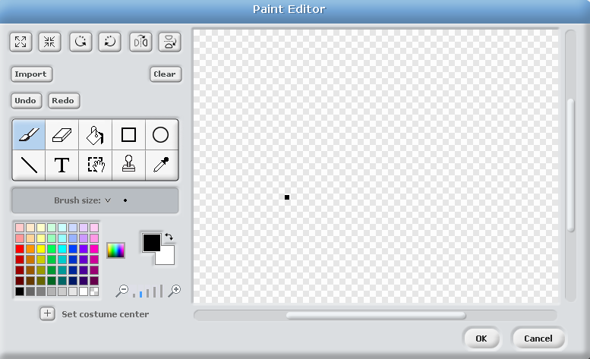
Paint Brush

Colour Palette

Fill Bucket

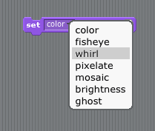
2. Make sure that the butterfly is selected. Move the set colour by effect script from the looks menu. Select whirl effect.

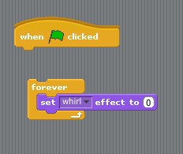
3. You will also need blocks from the control menu, when green flag is clicked and forever. Click them together like this.

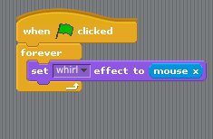
4. Look to the sensing menu and find mouse x. Add this to the block so it now looks like this.
What do you think this will do? Press the green flag to test it.

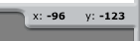
Notice the X value changes when you move the mouse.

5. Try adding in more effects and mouse y. What happens to the Y value when you move the mouse? What is the difference between mouse x and y?
