Scratch Help Document
Beat It – Moving a sprite to a beat
1. Click on paint new sprite. Make your own dancing dude! in the paint editor.
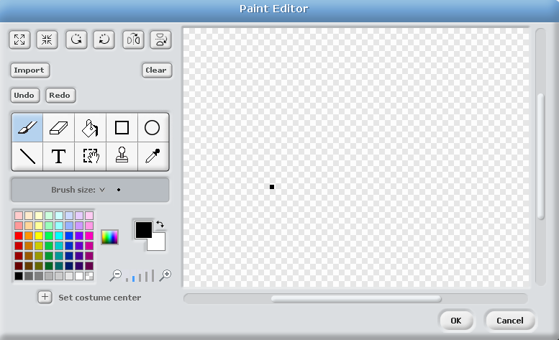
Paint Brush

Colour Palette

Fill Bucket

2. Make sure that the dancer is selected and grab a move block, drag it into the middle. Select a play drum block and click them together.

Testing – Click the blocks once to play them or to listen to the sound.

3. Next select the copy tool, drag across to the blocks and duplicate them.

4. Change the new move block to -10 steps and choose a different drum from the list.
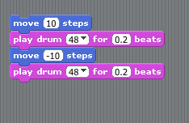
Change around the numbers, what happens?

5. Add in some control blocks – forever and the when green flag is clicked
What do you think this will do? Press the green flag to test it.
