You have now travelled further inland and climbed to the top of the lookout tower, looking around you can see many features and what looks like a small village. You need to learn how to give directions this will ensure you can travel there safely.

Day 2 – Giving accurate directions

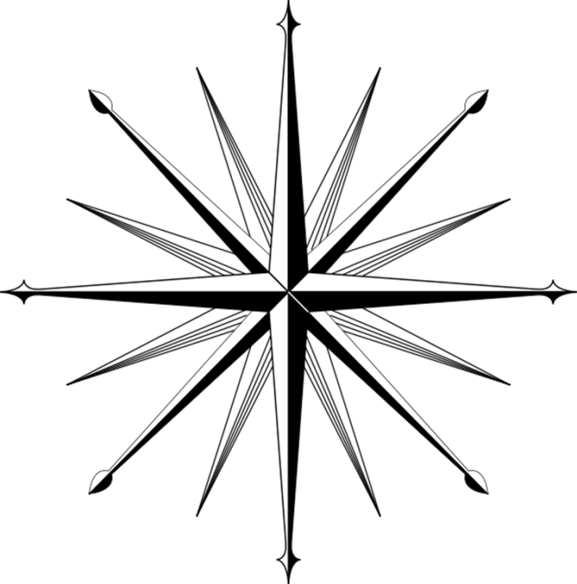

Refer back to the map and give the directions to each location:
4 Points
Rose and Bernard’s Cabin…………………………. Stone Bench…………………………………………
The Tempest ………………………………………… Statue of Tawaret ………………………………….

8 Points
The Volcano …………………………………… The Barracks …………………………………………….
The Crash site ……………………………………….. Hydra Island ……………………………………………

16 Points
Hydra Island ………………………………… The survivors beach camp ……………………………
The others camp ……………………. The heart of the Island ………………………………

To get to the barracks you will need to walk from the lookout tower, you need to pass memorable locations in order to give accurate directions, the more landmarks you can identify the better the directions will be. Mark the route you will take on the map below and write accurate instructions with directions for your teammates.

