Scratch Help Document
Dancing Queen – Learn about costumes and music loops

1. Click on the stage icon, you need to select this as you will be adding a background.

2. Select the background tab and import. Choose any of the backgrounds in the folder.
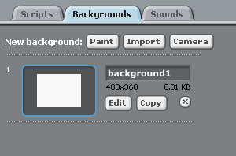

Background Tab
Import Button

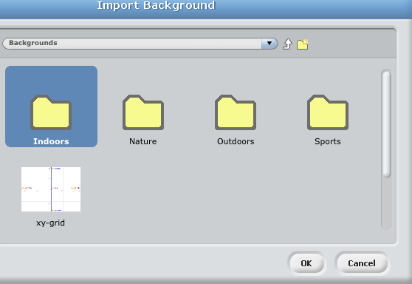

3. Now you need to select Choose new sprite from file and choose people. You need to choose a person which has loads of different positions. This will allow you to animate your sprite later.
Choose new sprite from file

4. Click on the costumes tab and import. Choose all of the different moves for that person. You can click through them to see what they look like.

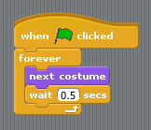
5. Drag the next costume block across and click to see what happens.

6. Now add in some controls, add in the wait block, I reduced the seconds down to 0.5. Add in the forever and when the green flagged is clicked blocks.

7. Our sprite now needs some music. Click on the sounds tab and import. Choose any sound that you would like.

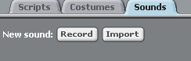

8. Now to get the sprite to move to the music. Add in the play sound until done block.

9. Finally add in the forever and when the green flagged is clicked blocks.

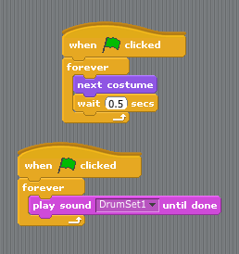

10. Check it out! And test it, try different sounds and costumes!!

