Homework 4: Bits/Bytes/Nibbles
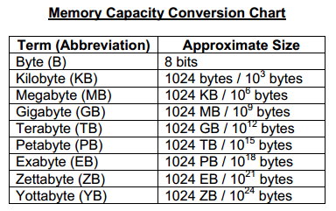
Explain the difference between metric and Binary:

Convert each of these:
3 Megabytes into Kilobytes:
1 TB into Kilobytes:
4 Kilobytes into Bytes:
5 Petabytes into Terabytes:

