Networks Exam Practice
10 marks

- Explain an Advantage of the Bus topology over Star networks (2 marks)
- Name a network which is least likely to be connected to the public switched telephone network (1 marks)
A) Mobile phone network
B) Nationwide telephone network
C) A secure telephone network in a military base
D) A telephone network allowing cooms withing a single building and beyound
- Servers are connected using a wired ethernet LAN. Describe two characteristics of a wired Ethernet LAN (4 mark)
1.
2.
- Explain two benefits and a disadvantage of RING networks over BUS networks (3 marks)
benefit 1:
benefit 2:
Disadvantage:

Answers:
- One mark for point, another for explanation:
Less set up costs (1) because there is less cable running to each client from the server/router (1)
2. C (1 mark)
3. (4marks)
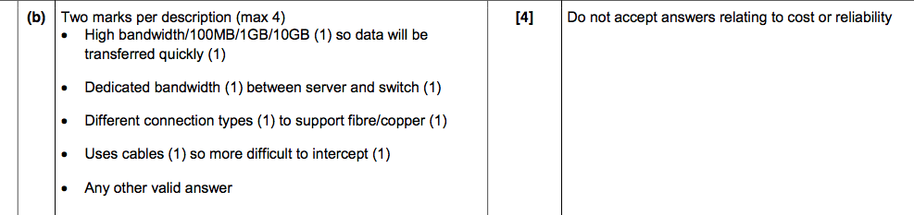
4. Benefits: Faster connection to server through router because of a direct connection (1 mark) and if there is a break in the system, not all clients are affected (1 mark)
Disadvantage: Most costly to install due to more cable being used (1mark)

