5.5 Digital Security

Starter: (Find a example image for each below, this could be a brand product or screenshot of the security)

Anti-Virus and Anti-spyware

Usernames and passwords

Firewalls inc Packet filtering, Inspection and Proxy’s)

Permissions (define read-only/read-write)

Encryption

When complete, answer the exam question on the example of a bank :

(10 marks)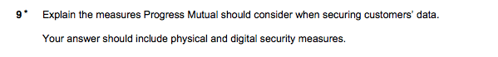

When complete, check against the mark-scheme below to mark yourself/partner.

Mark Scheme:

