Input and Output Devices
Input or output?
Device name:
Description:
Input or output?
Device name:
Description:
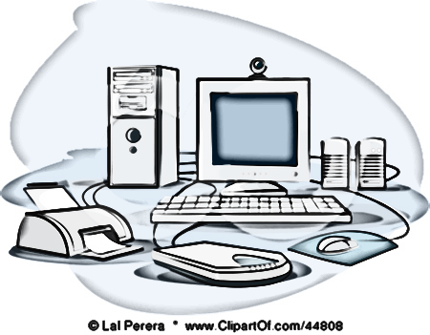
Input or output?
Device name:
Description:
Input or output?
Device name:
Description:
Input or output?
Device name:
Description:
Input or output?
Device name:
Description:
Input or output?
Device name:
Description:
Device | Input or Output? | Description | Give a benefit/limitation
Graphics Tablet

Plotters

RFID (Radio-Frequency Identification)

Sensors

Barcode Reader

Microphone

Joystick

Touchpad/Screen

Actuators

